PROJECT 3

Sales Dashboard using Microsoft Excel

Abstract
The Sales Dashboard is an Excel-based project developed to analyze sales performance and revenue generation. It calculates product-wise sales and provides insights into overall business performance through structured reports.

Objective
- To calculate sales revenue automatically.
- To analyze product-wise sales performance.
- To generate sales reports and summaries.
- To improve business decision-making through data analysis.

Tools Used
- Microsoft Excel 2016

Formulas Used
- Multiplication Formula (Quantity × Price)
- SUM()
- SUMIF()

Methodology
- Created a sales database containing product details.
- Recorded quantity and price information.
- Calculated sales revenue using Excel formulas.
- Analyzed product-wise sales using SUMIF formulas.
- Generated summary reports for performance evaluation.

Result
The Sales Dashboard successfully calculated revenue and provided clear insights into product sales performance.

Conclusion
The project helps in understanding sales trends, revenue generation, and business performance through data analysis.
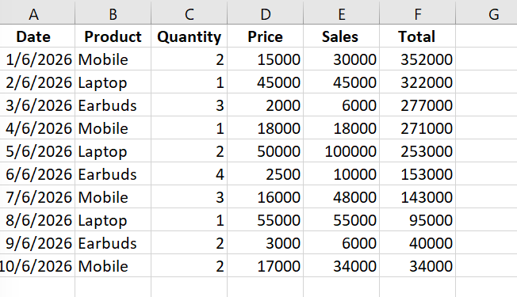

STUDENT DETAILS PAGE
Name: Ranimekala Venkata Lakshmi
Branch: Computer Science Engineering (CSE)
College: PSCMR College of Engineering & Technology, Vijayawada
Academic Year: 2024 – 2028
CGPA: 7.13/10
Project Guide: Self Learning Project
Tools Used: Microsoft Excel 2016
Submitted By:
Ranimekala Venkata Lakshmi
B.Tech CSE (3rd Year)

